**Without Isolation**

**My Permits –** This includes permits that you own and are responsible for.

**Dept Permits –** Permits owned by the department, but still under your purview.

**Open Permits –** Permits that are in progress, meaning they haven’t been completed yet.

**Closed Permits –** Permits that have been completed and are now closed.

**AVI -** This includes AVI’s that you own and are responsible for

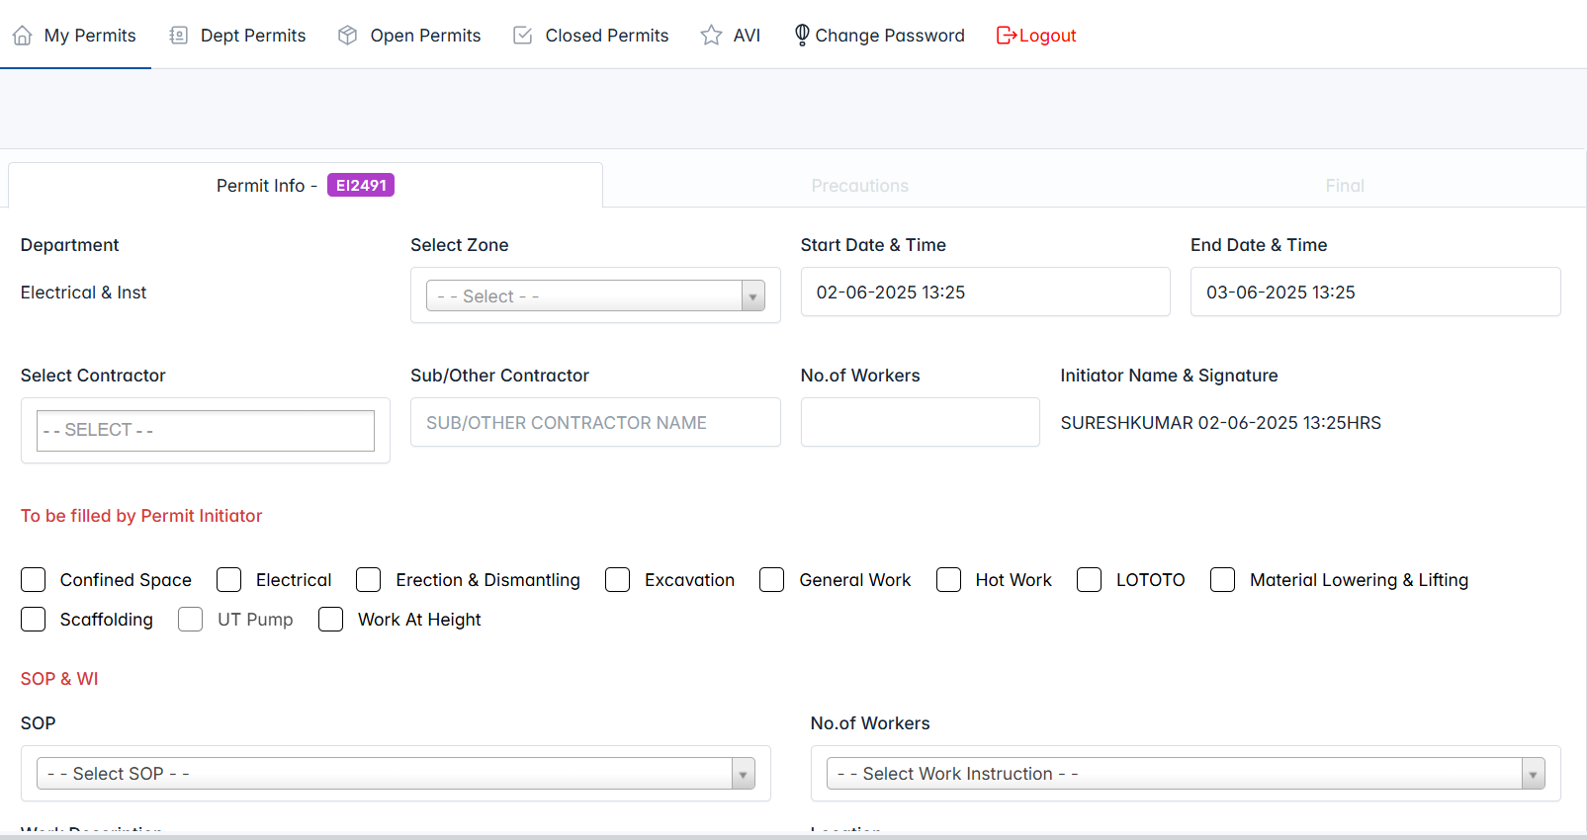

**Step - 1**

Requestor must fill out all the mandatory fields before submitting the permit request. If any required field is left blank, the system will display an error message, alerting the requestor to complete all mandatory inputs.

**Note : When initiator raise the new permit, we will check the Latitude and Longitude range of his current location to the selected zone. In case, if its out of range, system throws the error message and prompt the user to change the status to "Draft".**

**Furthermore, if the user holds the raised permits without taking any action, the system will display an error message and prompt the user to fulfill the existing permits.**

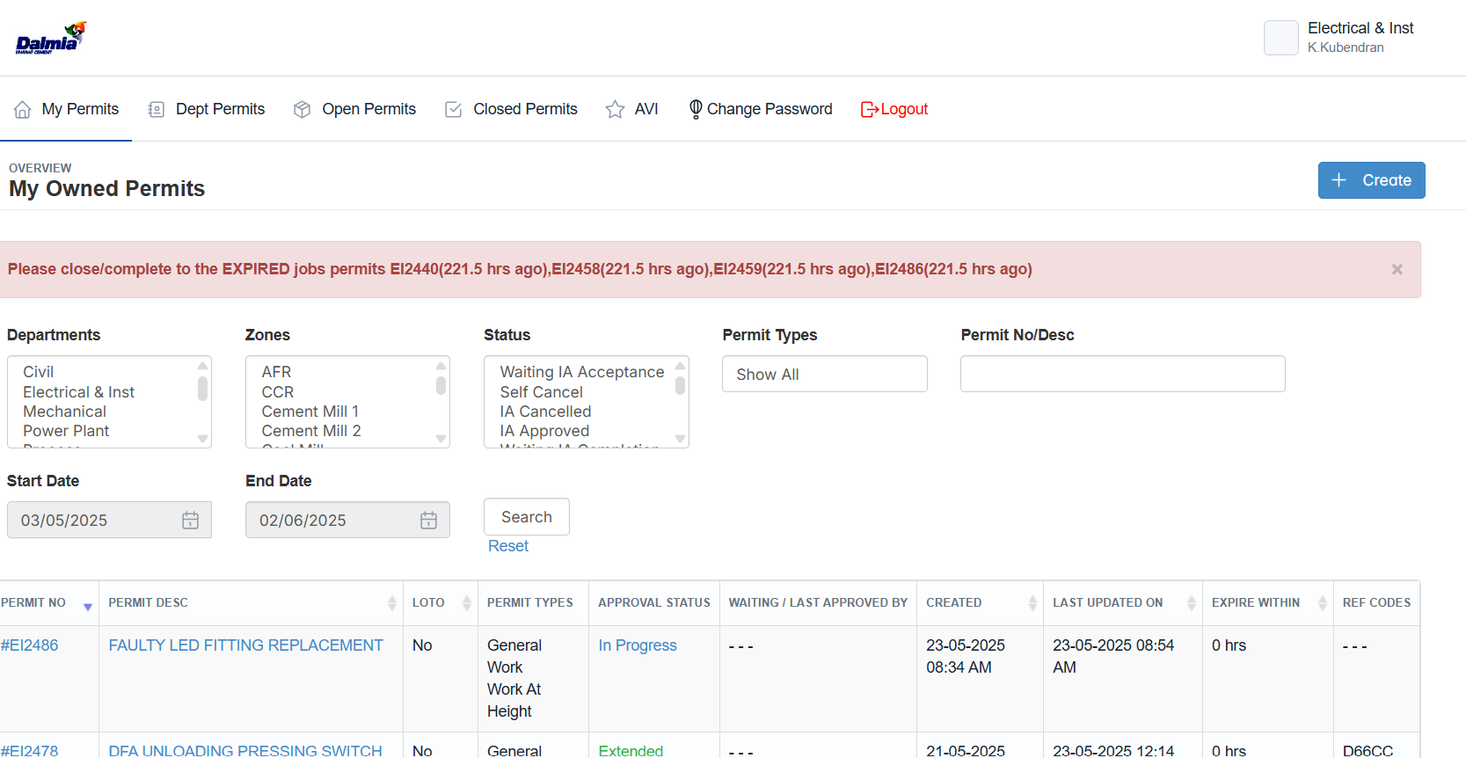

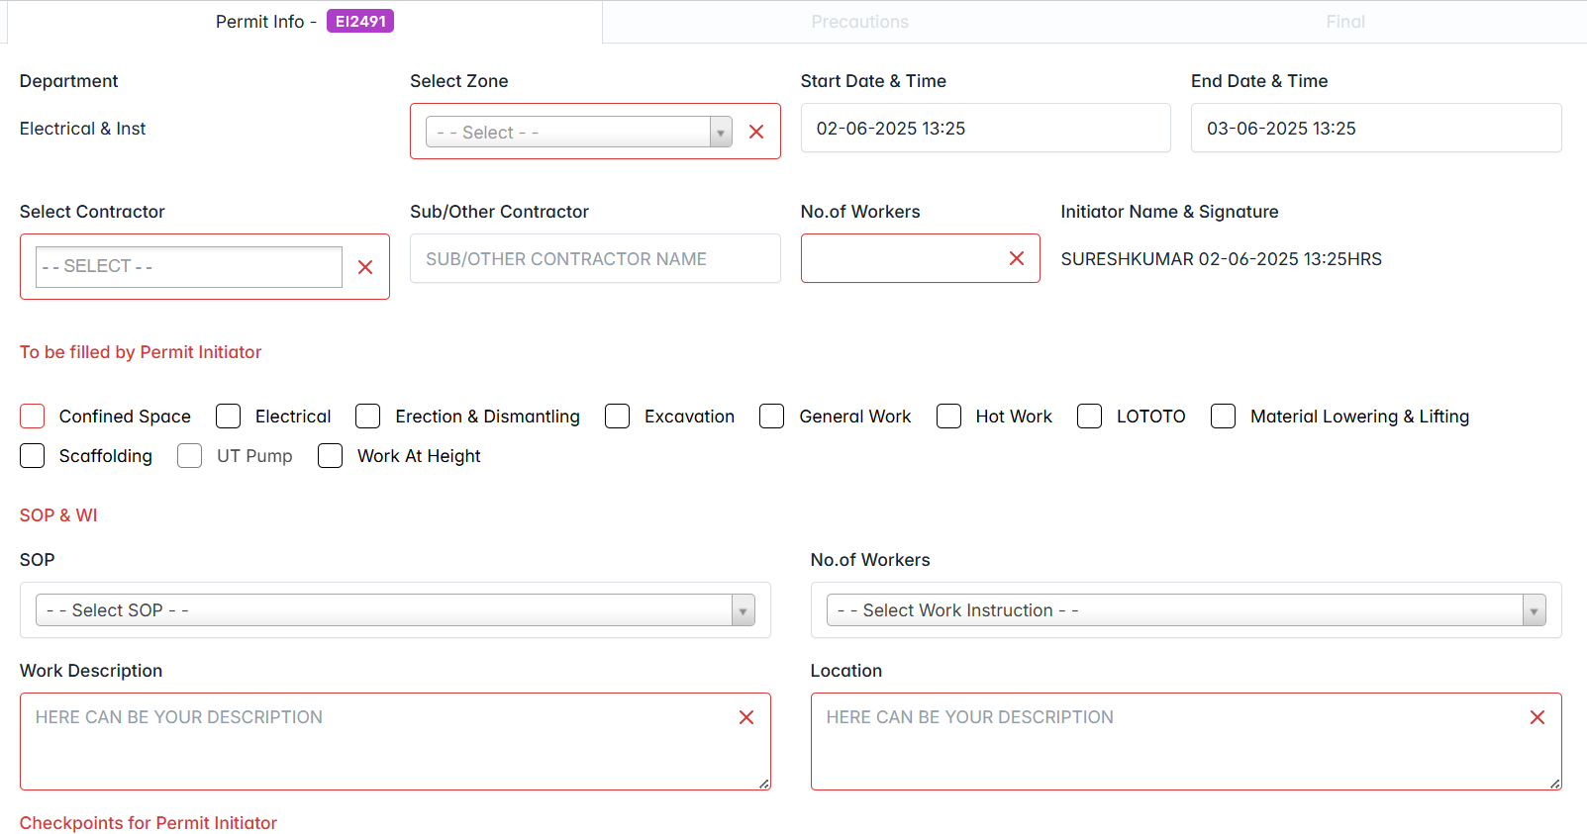

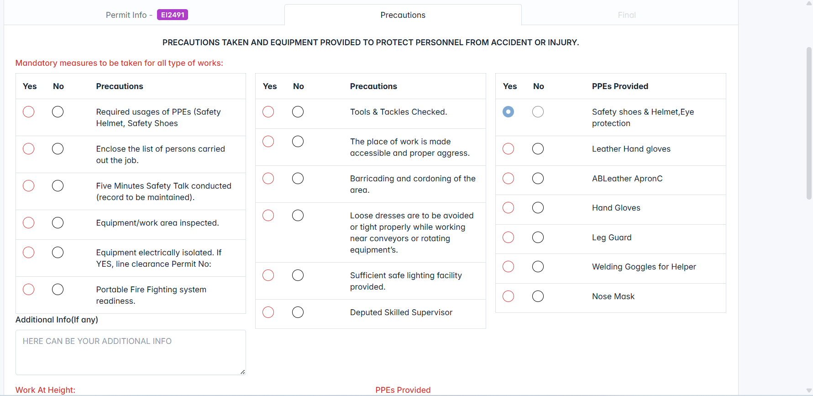

Initiated the new permit successfully. It’s started to listing under “My Permits”. Status is changed to “**Waiting IA Acceptance**”. Initiator can edit the permit info until the Initiator approve the permit.

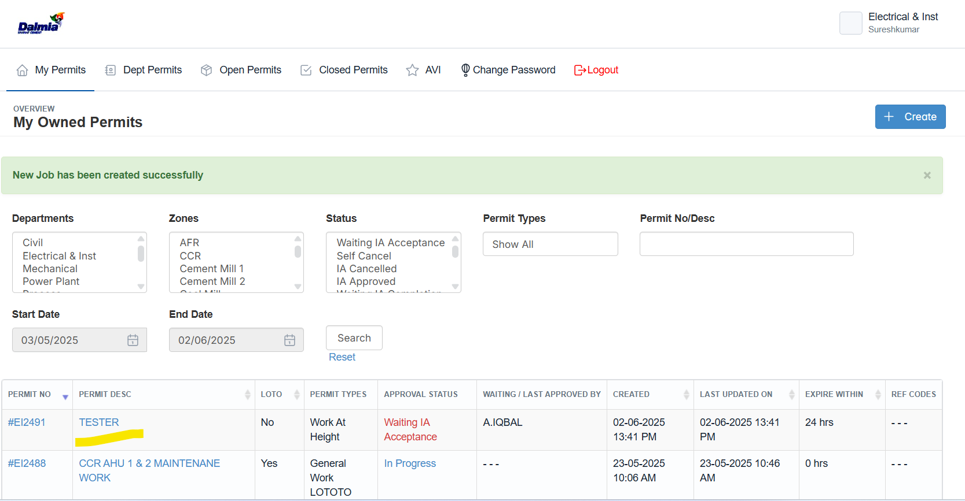

If, initiator won’t like to continue the permit, they can cancel the permit before getting approval from “Issuer”

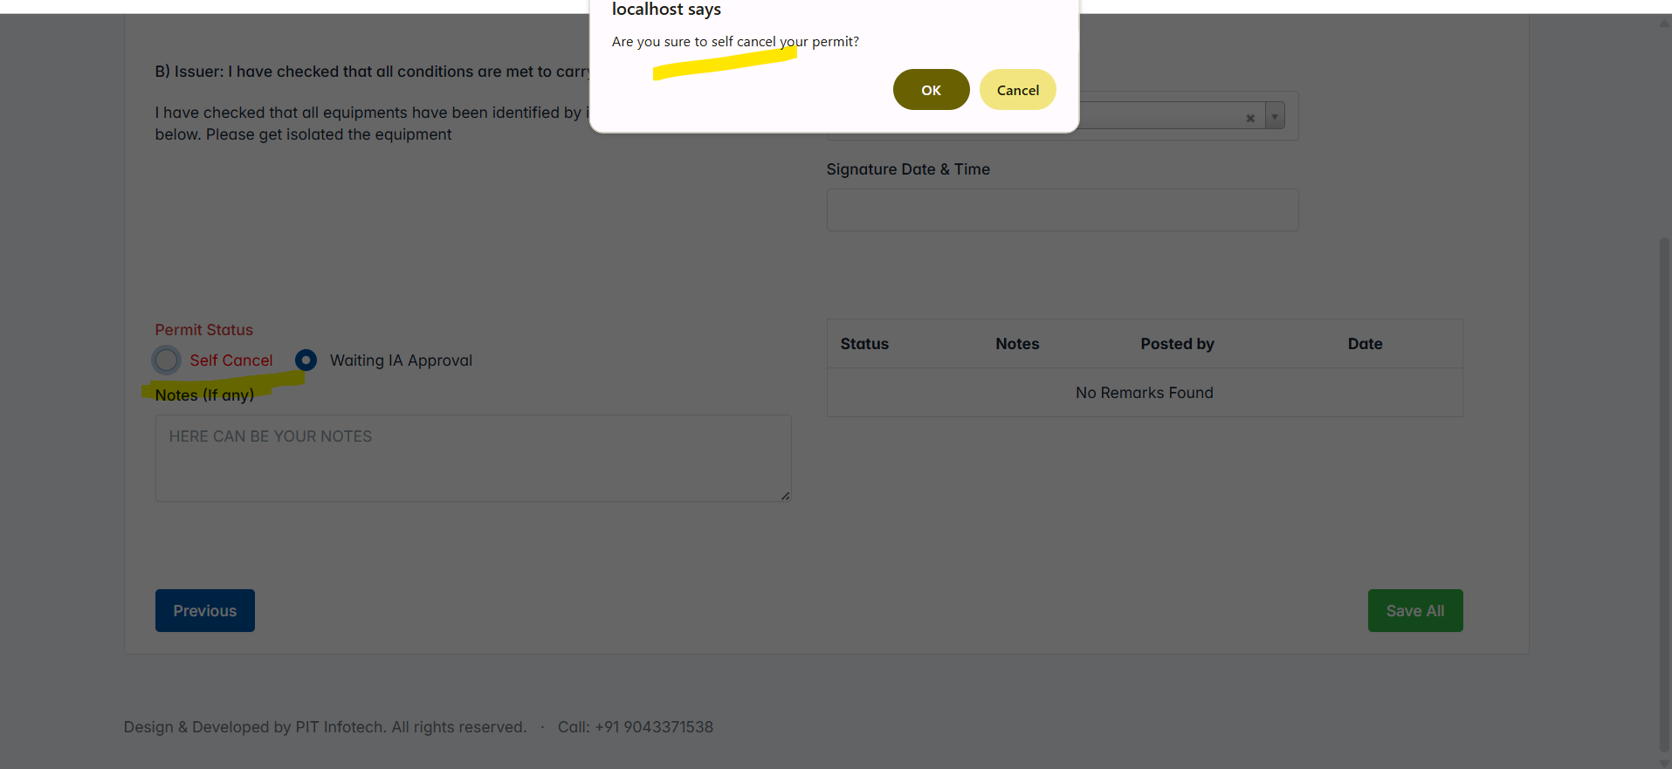

**Step - 2 Responsible Person : Issuer**

Logged as “Issuer” and started the permit info.

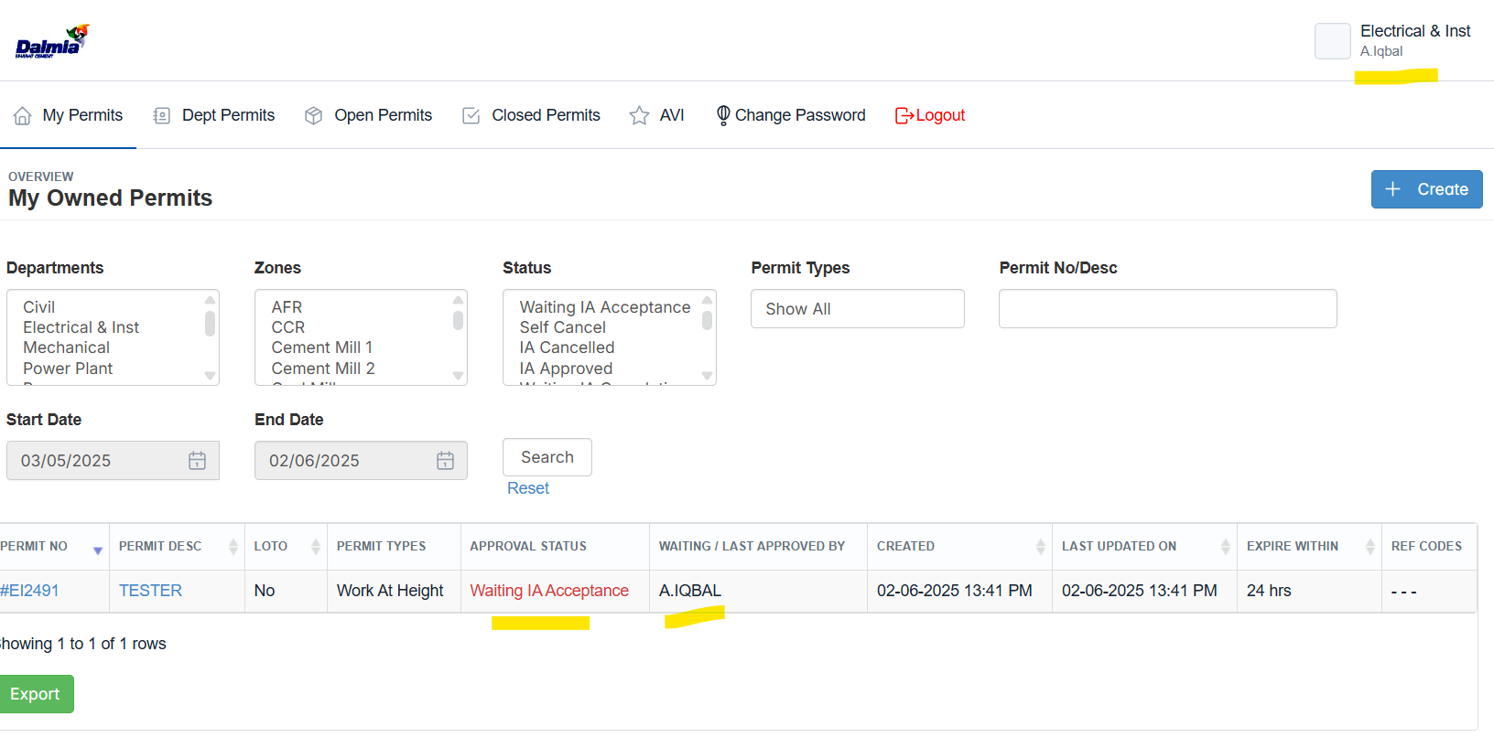

Issuer has the ability to either approve or cancel the permit. When the permit is approved, it moves forward to the next step(**Final Submit**) in the process, and if not approved, it is sent back for revisions or further review.

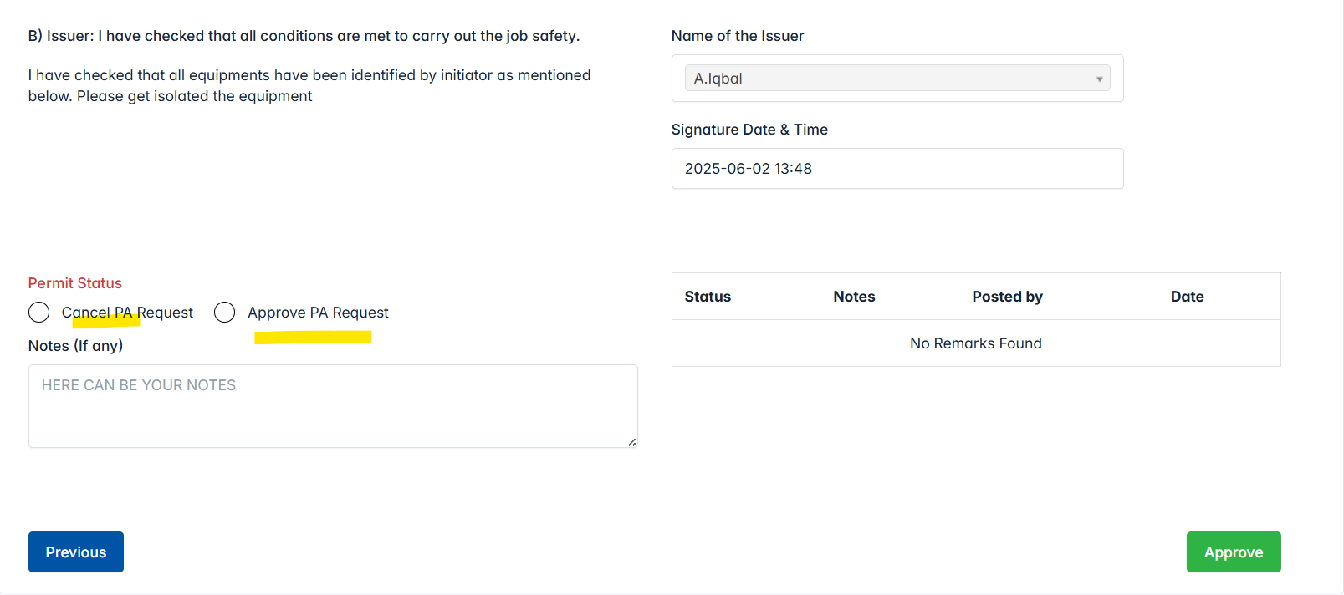

**After approved by Issuer.**

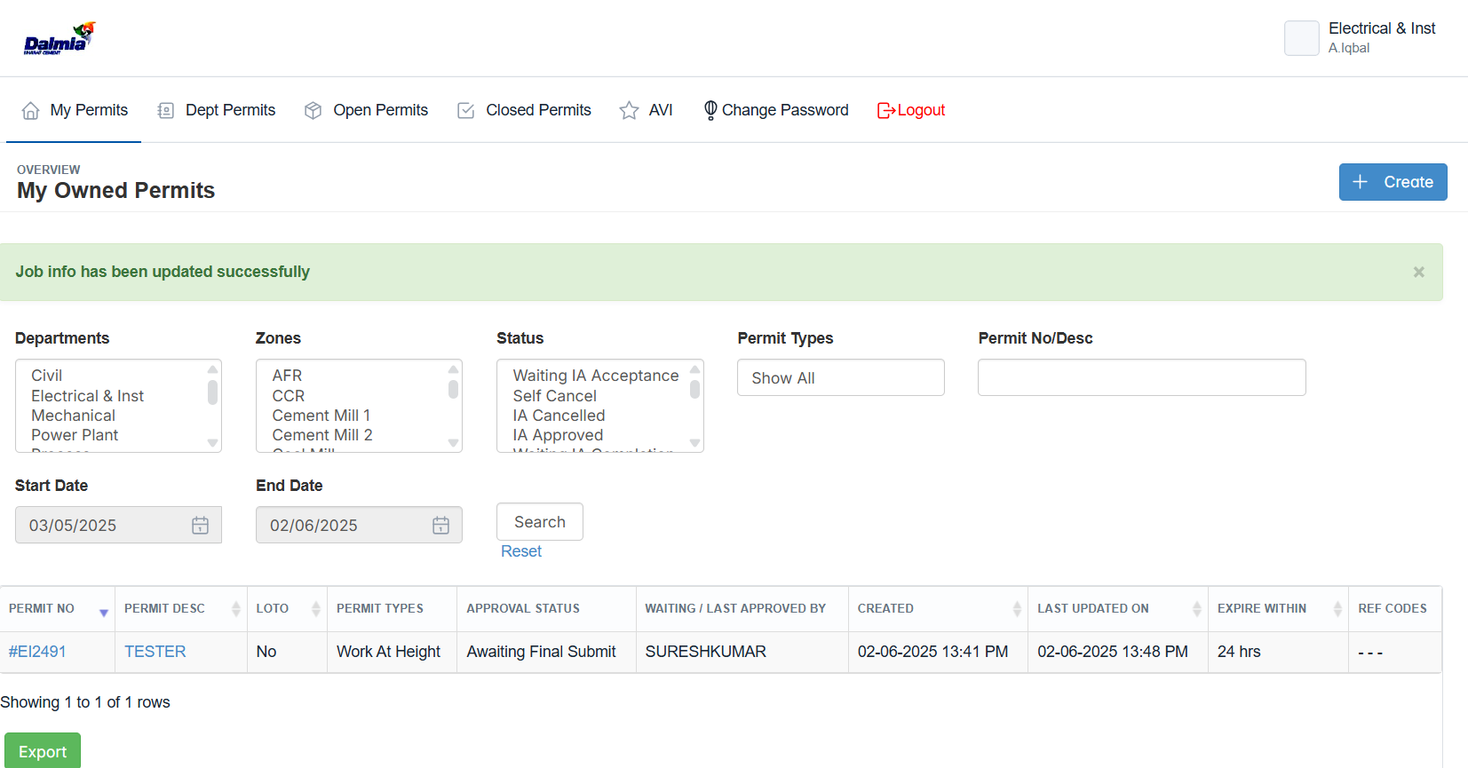

**Step - 3 Responsible Person : Initiator**

Once, the permit reach “Final Submit”, requestor can be the confirm that and start their works.

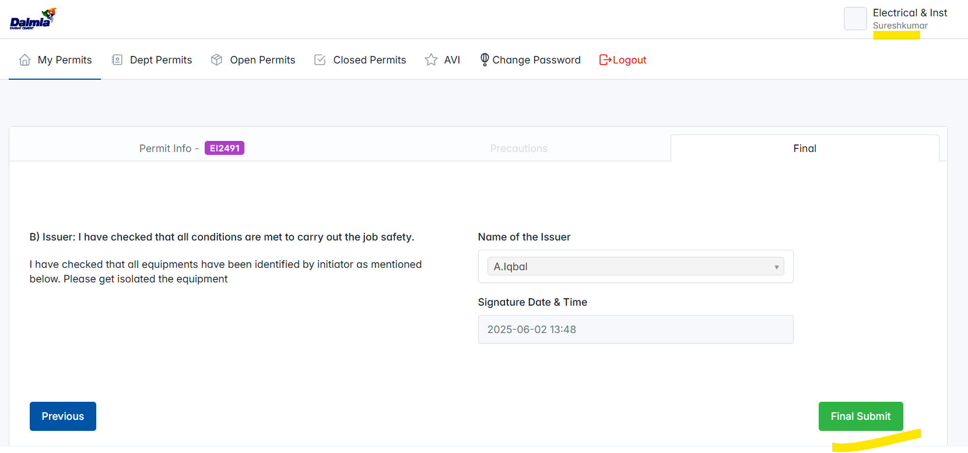

**Logged as “Requester” and done the Final Submit. Now, the permit status is changed “In Progress”.**

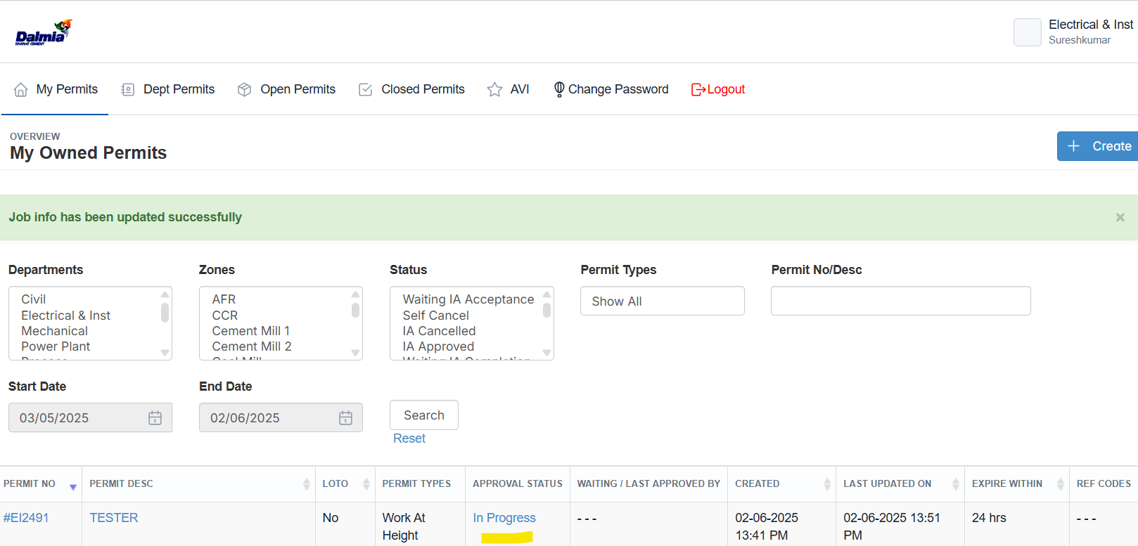

Also, when the final submit step is completed by the user, they can get to download the permit info & WPRA in PDF format.

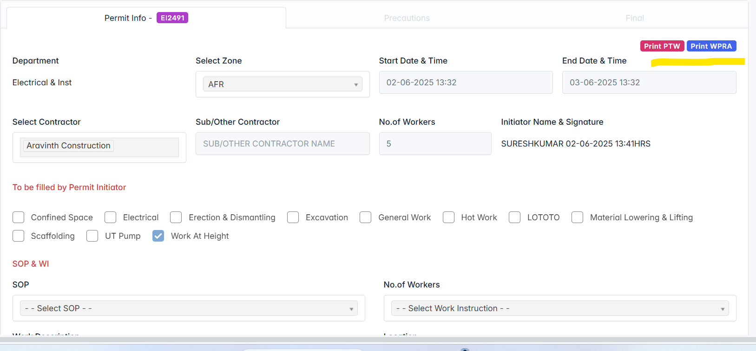

**Step - 4 Responsible Person : Initiator**

**From the "In Progress" stage, there are three options to move the permit forward.  
  
Completion –** This likely signifies that the permit is finished and can be finalized.

**Cancellation –** This option would stop the permit process entirely.

**Extension –** This allows for more time to work on the permit before moving forward.

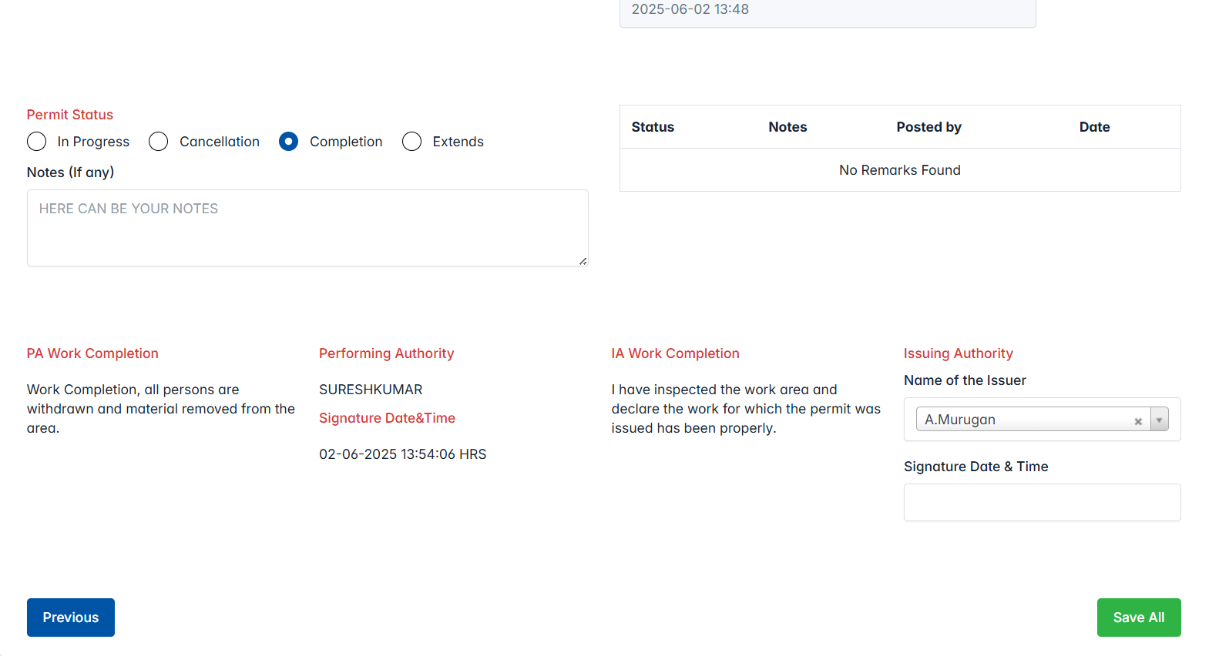

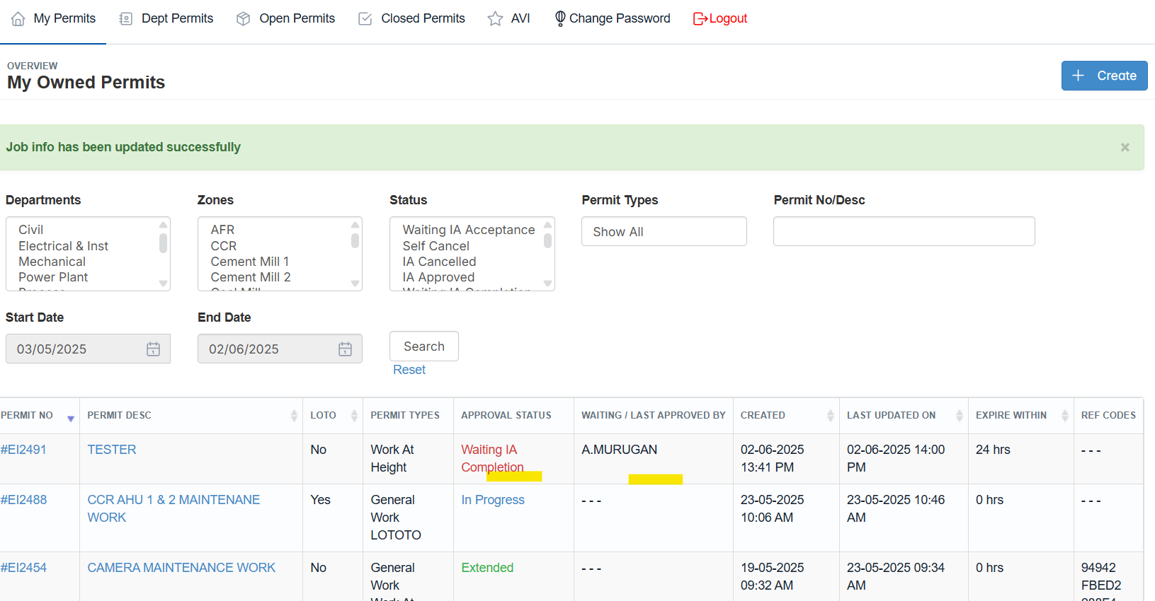

**Step - 5 Responsible Person : Issuer**

Logged as issuer to approve the Cancellation/Completion the permits requested by the requestors.

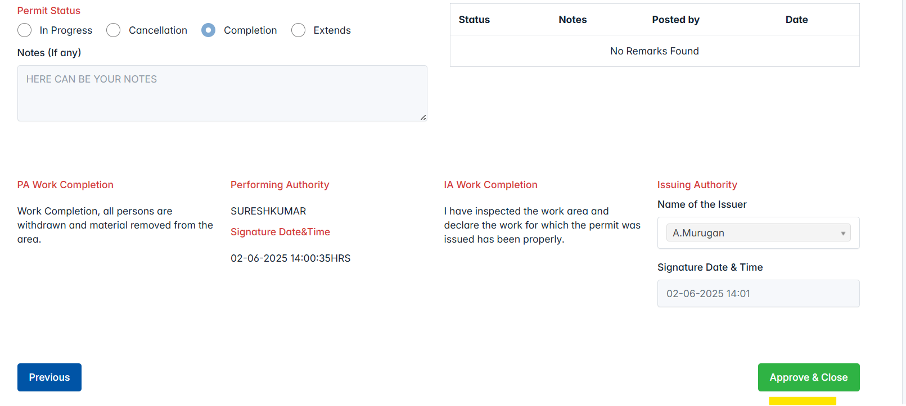

**That’s it. Now, the permit is completed and moved to “Closed Permit”.**

